This script will demonstrate how to shoot out a grappling hook when pressing and holding right click

**Step 1 – Creating the Scene**

Much like the previous tutorials, we will need to set up a player controller and camera controller to allow our player to run around and rotate the camera using the mouse. These can be done by referring to previous tutorials. The scene will consist of 5 things:

1. A floor
2. 2 large, wall-like cubes, titled “Respawn” and “Death” respectively
3. The colliders for these 2 walls
4. The player (**Must** be tagged as “player”)
5. An empty GameObject named “RespawnPoint”

The player and floor can be made by referring to previous tutorials, though for the Respawn and Death walls we will need to give them different colours to differentiate them. This can be done by right-clicking onto the unity editor and creating a material. For convenience, the death wall should be coloured red, whereas the respawn wall can be coloured whatever you choose (in my instance, purple). The scene should look like the following:

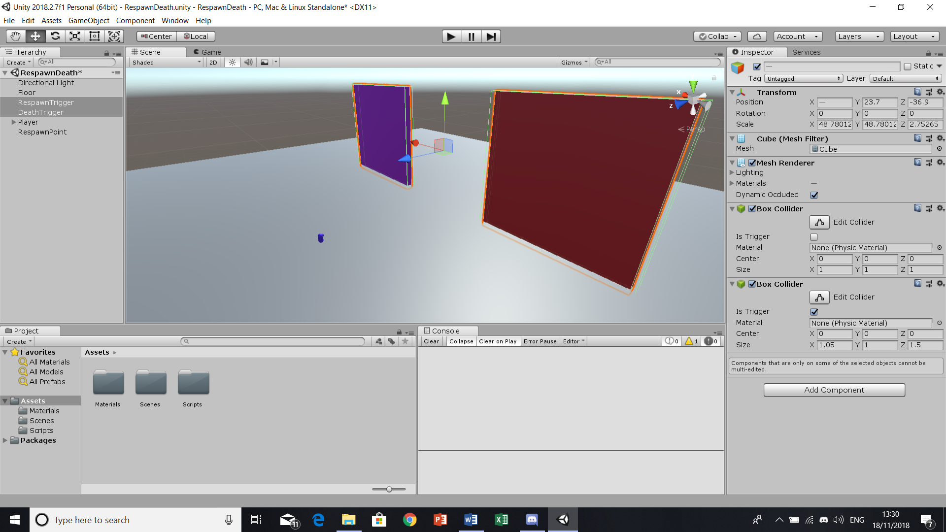

**Step 2 – Setting up the Colliders**

With the walls created, we need to attach additional box colliders onto each cube named “Respawn” and “Death”. These colliders must have the “Is Trigger” box ticked, allowing these colliders to trigger events. It is **important** to ensure that the additional box colliders are slightly larger than their “original” counterparts, this is so that the player will trigger the scripts’ effects just a little before they collide with the wall, meaning the player does not need to forcefully wedge themselves into the wall to bring about the Respawn/Death effect. It should look like the following:

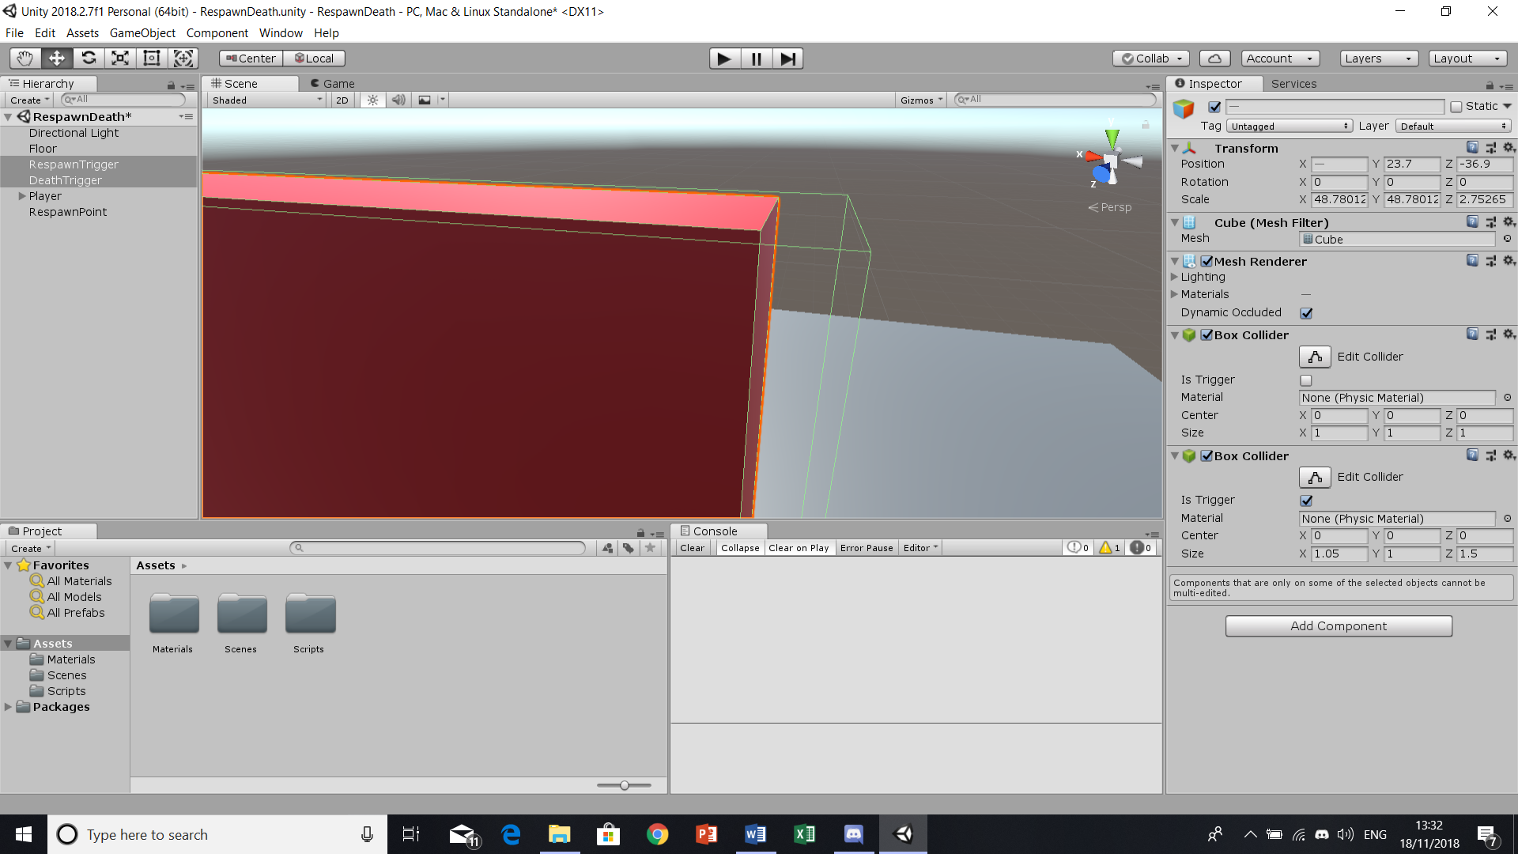

**Step 3 – Creating the Respawn Script**

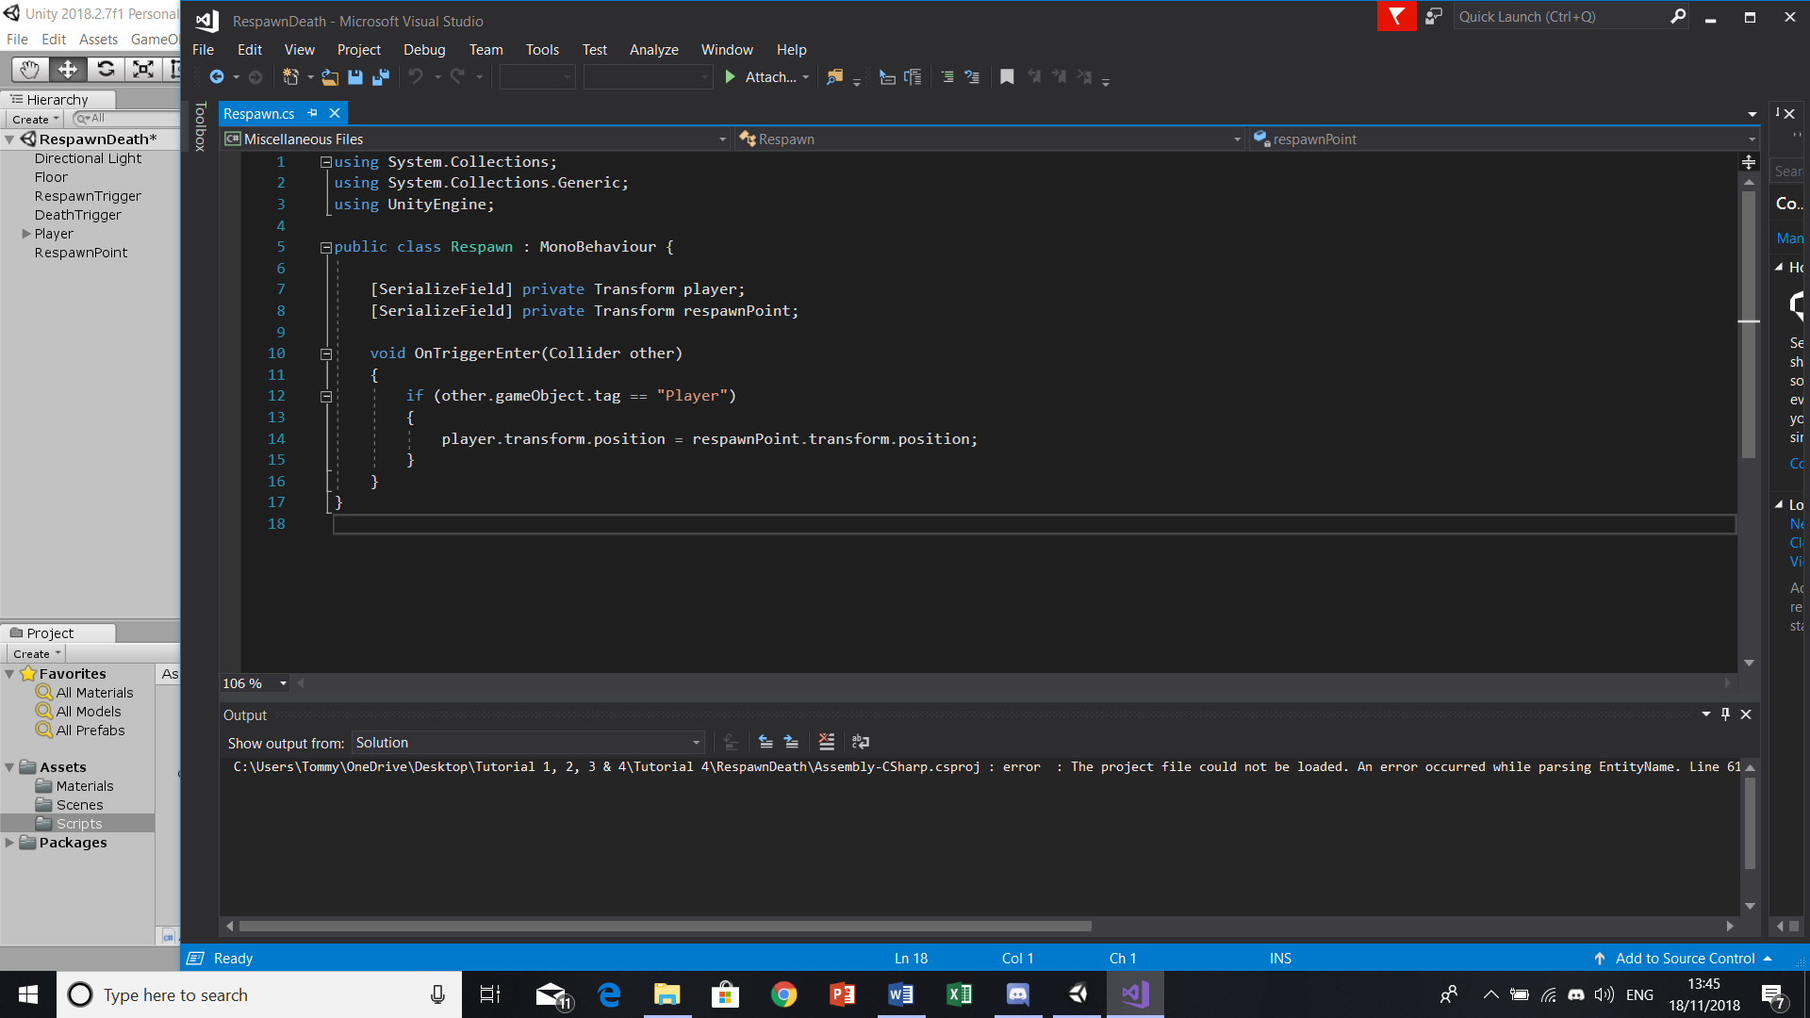

First, we must set two transform variables; “Player” and “RespawnPoint”. Once these variables are in place, the following “void OnTriggerEnter” describes what is to happen if another object collides with the collider attached to the object this script is applied to, as seen by “(Collider ‘other’)”. Next, we’ll be making an if statement to describe what happens when another object collides with the trigger. In the instance of the respawn, it will transform the position of the player back to the position of the respawnpoint (the empty game object placed onto the scene). Once this is placed onto the wall/cube, you will need to drag the player and empty gameobject (respawn point) onto the parameters found within the inspector. It will look like the following:

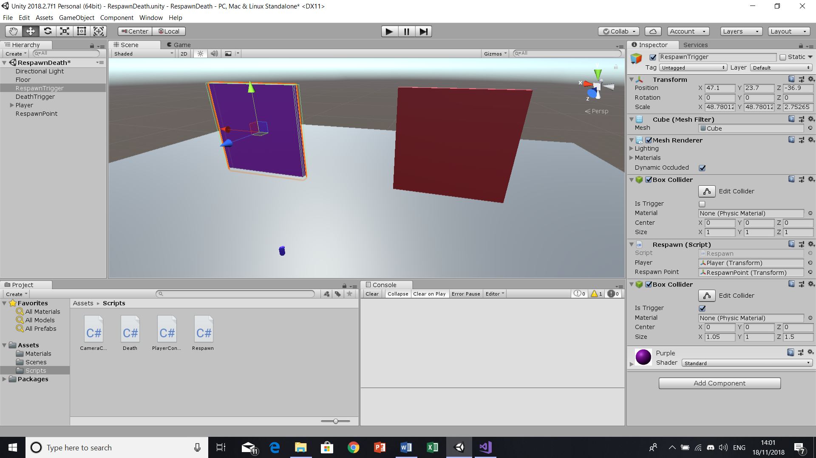

**Step 4 – Creating the Death Script**

The death script (much like the Respawn script) requires an “OnTriggerEnter” void, allowing it to detect what is within a certain radius of it, as well as what it needs to do should something be detected. However, the key difference between the respawn and death script is that the death script is not bound to any objects. In this case, it simply looks to destroy whatever object tagged as “player” intrudes within its box collider vicinity. It should look like the following:

